CS 499 Module One Assignment Template

Complete this template by replacing the bracketed text with the relevant information.

- Self-Introduction: Address all of the following questions to introduce yourself.

  - How long have you been in the Computer Science program?

My journey with SNHU began in March 2024, so it has been about 2 years and 5 months since I started and will be 2 years and 7 months upon completion of this class. I had previously taken classes at Golden West College shortly after I left high school and had also received an AA degree from ITT Technical Institute, both of which helped form the foundation of required classes to begin studying at SNHU.

  - What have you learned while in the program? List three of the most important concepts or skills you have learned.

Full Stack development is at the top of my list for both an important new skill and concept that I have learned, as it will contribute directly to my goal of becoming a software developer. Learning how to design, develop, and debug each layer of the full-stack process has given me insight into how all the components work together. I had previous experience with APIs and specifications, so seeing how the underlying code works has helped me complete my understanding of the architecture. This, in turn, allows me to think about how the whole unit works together while allowing each portion to be maintained and coded separately. In many cases, developers prefer to focus on one area - Front End versus Back End, or even specializing in databases - but I feel confident in my ability to move across the entire range and believe I could enjoy being a full-stack developer.
Hand in hand with Full Stack is the work done on UI design and web pages. A few of the classes I've taken have delved into the creation of user interfaces and displaying them to users via a website. With the trend toward online services and moving programs that were once downloaded to a user's computer into browser interfaces, it is clear that knowledge of how to create and modify web pages is a necessary skill in business today.
Getting hands-on experience with Java, JavaScript, C++, and Python has shown me both the differences and the similarities between them. While syntax may differ between languages, the concepts of logic and organization are equally applicable. This has given me increased confidence that I can pick up any language and move forward with it, even if I am not initially familiar with it, as the underlying concepts and strategies for developing software will still apply.

  - Discuss the specific skills you aim to demonstrate through your enhancements to reach each of the course outcomes.

Communication is the key to collaboration. As such, I plan to demonstrate clear communication skills across all the various aspects of my project. Clear designs help build well-implemented and understood applications and form the foundation of the development process. Including clear comments in the code, descriptive headers, good naming conventions, and other industry-standard communication methods all contribute to understanding the code and being able to effectively communicate about it to diverse audiences. For example, code comments help developers understand code intent, while a written overview document will be viewed by both technical and non-technical team members and thus needs more descriptive and less technical terms.
Methods of communication vary in business, so I plan to demonstrate that I can communicate through a variety of different mediums. While I prefer text, I have professionally provided presentations and training, as well as regularly hosted stand-ups as a normal part of my work requirements. I can use these various mediums to demonstrate my improved understanding of technical processes and procedures.
Design choice trade-offs include both technology choices and time choices. As a technology choice, I plan to adapt the currently administrator-only SPA to provide an interface for user searching, sorting, and filtering of trip data. Reusing existing code and structures is a core computer science principle for reducing work and defects. While I could build this functionality by enhancing the existing Express page with queries directly against the database, searching and filtering are likely to involve extended user interaction. Extended dynamic interaction is better served by an SPA due to its improved responsiveness compared with using Express to build a new page for each query and serving it from the back end.
One observation about time use in the software industry is that even good features can be left undeveloped because other needs have a higher priority. Other, more valuable features are often naturally prioritized, and critical defect fixes can take precedence over feature development. In short, deciding what to do and what features to implement always involves understanding that there is an inherent trade-off in not doing other work. By making these selections for improving aspects of the Travlr website and determining the order of those improvements, I demonstrate my knowledge of how design choice trade-offs can be managed and show that I can implement core computer science practices and standards.
In business, delivering value is the primary measure of success. Delivering value includes providing both functional code and useful features. Demonstrating the delivery of value in this project will focus on creating new features related to sorting and searching, which will allow users to find what they need without frustration and compare different options by choosing relevant sorting options. Reviewing a small number of options is easy, but with the expectation that a company will grow and its offerings will likewise increase, sorting and filtering become a necessity, allowing the demonstration of a clearly valuable industry-specific goal.
For my current project, a security mindset is perhaps the easiest to demonstrate. I have been a professional Quality Assurance technician, and I still perform routine verifications as part of my current job, so testing is built into my development process. When I can, I prefer to make small incremental changes and test their functionality; this helps me identify immediately when there is a defect that needs addressing. With the inclusion of an API in my project, it is imperative that the endpoints be tested thoroughly with the understanding that a hostile attacker will not just use the provided UI, but is very likely to send both legitimate and malformed requests directly to the API. As such, I can demonstrate my ability to implement security by testing the endpoints and implementing industry-standard error checking and responses to incoming requests.

  - How do the specific skills you will demonstrate align with your career plans related to your degree?

I have worked as a Product Owner for about 10 years, and as my education has progressed, I have been able to communicate more effectively with the developers on my team. The terminology in use and the processes and procedures they undertake to develop code have become familiar to me, not just as an outside observer, but as a fellow developer. This knowledge adds value to my skill set as a Product Owner and allows me to better judge project timelines, needs, and outcomes.

  - How does this contribute to the specialization you are targeting for your career?

While I do not have a formal specialization for my degree, my focus is on software development. I am currently a Product Owner focusing on managing multiple products and their deliverables; however, my goal is to move away from that role and into a development role. My current role involves a lengthy commute, so I have little time for outside projects, and the switch from veteran Product Owner to entry-level developer would involve a significant reduction in compensation; I will have to carefully assess how I can transition. With my new skills, I plan to seek out a remote or more local Product Owner position to free up time to develop self-directed coding projects in order to build up my portfolio. The skills and focus from my degree have given me the tools to understand how to accomplish this.

- ePortfolio Set Up:

  - Submit a screen capture of your ePortfolio GitHub Pages home page that clearly shows your URL.
    - You already have a repository in GitHub where you uploaded projects in previous courses. Your ePortfolio will reside in GitHub but can link to work at other sites, such as Bitbucket.

  - Use the GitHub Pages link in the Resource section for directions on:
    - How to create your GitHub website and publish code to GitHub Pages
    - Issues, such as adding links to other sites

  - Paste a screenshot of your GitHub Pages home page with your URL clearly showing in the space below.

https://michael-j-murphy.github.io/

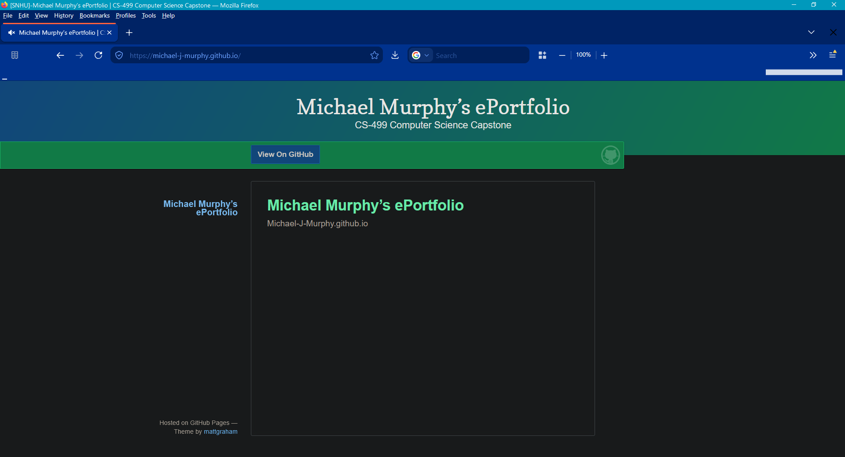

- Enhancement Plan:
  - Category One: Software Engineering and Design
    - Select an artifact that is aligned with the software engineering and design category and explain its origin (and categorical alignment).. Submit a file containing the code for the artifact you choose with your enhancement plan.

For each of the enhancement categories, I have chosen to enhance the CS-465 Full Stack Development I Travlr website project. This project is built on the MEAN (MongoDB, Express, Angular, Node) stack, with a customer-facing webpage served by Express using Handlebars, a Single Page Application (SPA) administrative site, a RESTful API that connects the SPA to the back end, and a MongoDB to serve the stored data, which include trip information and user login data.
For software engineering and design, the focus will be on the API portion, where security can be improved, and on refactoring the code to add try...catch error handling.
The plan outlined below aligns with the requirements of this category by making significant changes to the program design, reliability, security, and maintainability to bring it into a more production-ready, industry-standard state. While some of the work involves correcting issues with the code, a significant portion is adding functionality which did not previously exist: try…catch code blocks to capture errors and centralizing that error handling.
The additional work to add authentication to the /register endpoint is also a software engineering and security improvement because it prevents exploitation by unauthorized users, and preventing duplicate tripCodes is a small but significant operational improvement that improves program integrity by preventing the addition of records that can interfere with database operations.

Note: Your artifact may be work from the following courses:

- IT 145: Foundation in Application Development
- CS 250: Software Development Lifecycle
- CS 260: Data Structures and Algorithms
- IT 315: Object Oriented Analysis and Design
- CS 320: Software Testing, Automation, and Quality Assurance
- CS 330: Computational Graphics and Visualization
- CS 340: Advanced Programming Concepts
- CS 350: Emerging Systems Architectures and Technologies
- CS 360: Mobile Architecture and Programming
- IT 365: Operating Environments
- IT 380: Cybersecurity and Information Assurance
- CS 405: Secure Coding
- CS 410: Reverse Software engineering
- IT 340: Network and Telecommunication Management
- IT 380: Cybersecurity and Information Assurance

    - Describe a practical, well-illustrated plan for enhancement in alignment with the category, including a pseudocode or flowchart that illustrates the planned enhancement.

For Software Engineering and Design, the revisions are focused on three areas: API refactoring and updates, protecting the /register endpoint with authentication, and ensuring uniqueness for the tripCode.
The most significant area of improvement is the API. During my testing of the API, there were a number of instances where the API received invalid data and simply crashed. At the heart of this is the flaw that the API lacks error handling. To correct this, I plan to implement centralized error handling middleware and to add try…catch error handling around database operations.
In order to prevent the creation of administrator accounts by unauthorized users, I will add authentication to the /register endpoint. This naturally requires that a default user be seeded to allow new installations of the software to start off with an administrative account they can use to configure other accounts.
Finally, my testing revealed that it was possible to add duplicate tripCodes to the database, and in doing so, it was difficult to edit or delete the duplicates. To prevent this issue, I will be updating tripCode to be a unique value to prevent duplication. The updated API error handling will allow an error to be properly returned for cases of attempted duplication.

API Refactoring
The majority of the work in this section will focus on the API, so the files in the travlr\app_api folder will be modified by these updates. The first step is to build out centralized error-handling middleware; this is a new component that will be registered with the Express application and will be used by each existing API function that produces errors to provide a single location for processing errors passed from the API routes and controllers.
The next step is to go through each of the files and functions for the API and add error-handling processes. In many cases, I have already marked these code areas with FIXME notes from my previous testing. For example, \travlr\app_api\controllers\trips.js lacks try…catch, and the err variable is undefined, so if at any time the code branch is run that includes the err variable, the program is expected to crash. Correcting these code issues will create the necessary framework to allow adding the new error-handling middleware to each section.

The following diagram provides an overview of the revised API, including the refactored error handling and centralized error handler middleware.

API Refactoring Diagram
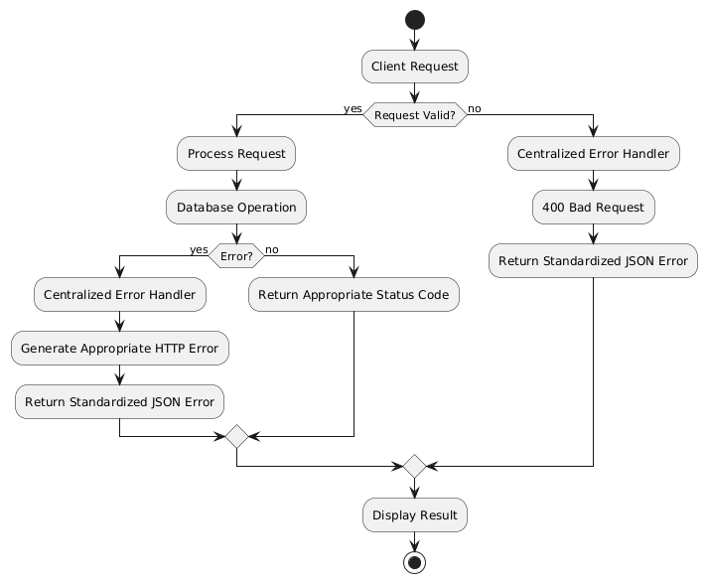

After the try…catch, missing variable definitions, and middleware are implemented, the next step will be to ensure that the errors provided are consistent with industry standards. Sites like https://developer.mozilla.org/en-US/docs/Web/HTTP/Reference/Status provide definitions of HTTP responses and information on how they should be used. I will use that to correct any HTTP response that is not following the standards.
Along with fixing the responses, I will need to define the standardized JSON errors and verify that all reasonable outcomes are covered, such as validating request content and handling malformed requests, such as when the request message itself has syntax errors.
While I tend to include testing as part of my implementation process, at this point I will need to proceed through a formal testing process. This process will validate the changes I have made so far and determine if there are any errors that need correction or possible error paths I have not yet accounted for.
Testing will also help me review how the errors are currently being provided to the front end. While most of the API testing will use Postman to test the API directly, I also need to verify the front-end web interface. It is at this point where I will begin implementing the change to the front end to display errors to the user in a user-friendly and unobtrusive way, such as a small banner at the top or bottom of the screen.

Authentication for /register endpoint
Adding authentication for the /register endpoint is the second portion of the work for this section. This will consist of adding existing authentication to the /register endpoint so that only users who are currently logged in can add new users. This is an important step in the process of ensuring the security of the website and a starting step along the road to a more robust security system overall.
This work occurs after the API refactoring because it builds on the improvements to the HTTP error handling to deliver the same standardized error responses. This work adds error handling to the existing flow. In cases where the user is logged in and the JWT is valid, the flow will proceed through the existing account-creation process. Requests without a valid JWT, such as those from users who are not logged in or whose JWT is invalid, will receive a 401 Unauthorized response.

The diagram below shows the completed process, including denying access to users who are not logged in, as well as validating the current web token, verifying the message content, and returning either a standardized error or the 201 Created response.

Protected Registration Endpoint Diagram
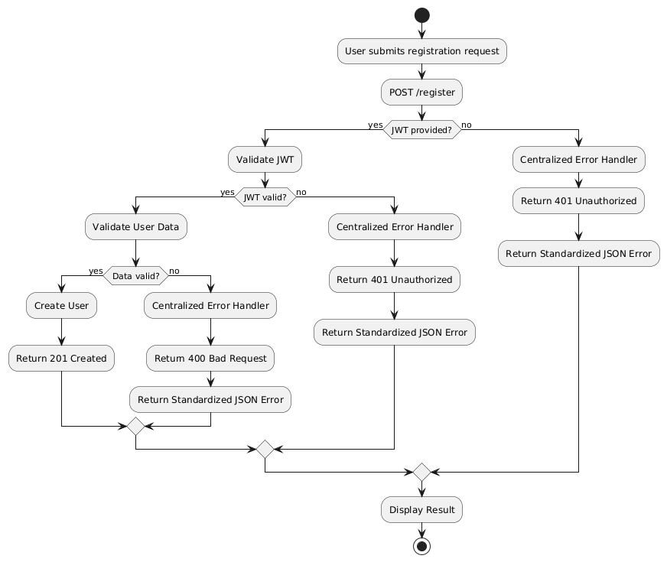

To allow for the creation of new users in freshly installed systems, the database must be seeded with an initial user account. This will be done in the same way that trip seeding is accomplished; this will require the seed.js file that is currently handling seeding the trips to be renamed to seed-trip.js in order to allow differentiation between it and the expected new seed-user.js file.

Prevent Duplicate tripCode
The tripCode value is used to identify each trip; however, this value is manually entered by the user. As such, it is subject to the possibility of duplicating an existing tripCode in a way that a database-generated identifier would not. Having tested duplicate tripCodes, I found that they interfere with further trip editing and deletion. In order to prevent this, the tripCode value will be constrained to contain unique values so that the database will not accept duplicates.
This work involves adding a unique index to the field so that MongoDB rejects attempts to create multiple trips with the same code. As with adding authentication to the /register endpoint, this also dovetails into the previous API refactoring and error handling.
Along with checking for duplicate tripCodes, this work will also validate the trip data itself to ensure that all the required fields are present and that they have appropriate data. For example, while most fields right now are simply text fields, the length field would be better as a numeric value that can then be interpreted. The changes here will be limited but will start the setup for the further work to be done in the Algorithms and Data Structures portion of the class.

The diagram below shows the enhanced trip submission process that includes both validating the trip data and the HTTP errors returned for invalid data and for a duplicate tripCode.

Trip Submission Diagram
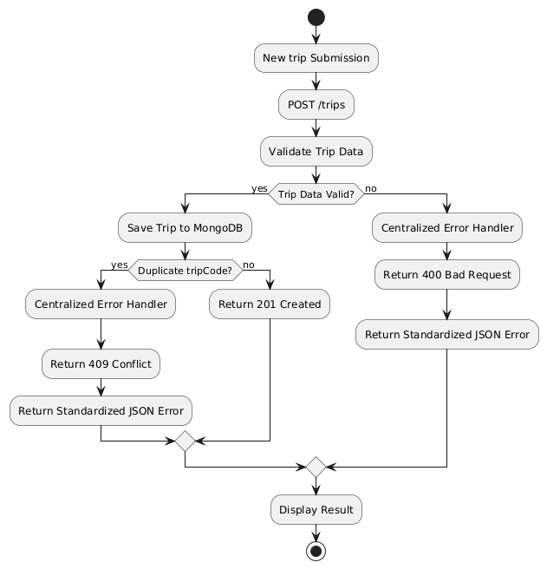

For this category of enhancement, consider improving a piece of software, transferring a project into a different language, reverse engineering a piece of software for a different operating system, or expanding a project’s complexity. These are just recommendations. Consider being creative and proposing an alternative enhancement to your instructor.

Think about what additions to include to complete the enhancement criteria in this category. Since one example option is to port to a new language, that is the kind of scale that is expected. This does not mean you need to port to a new language but instead have an equivalent scale of enhancement. Underlying expectations of any enhancement include fixing errors, debugging, and cleaning up comments, but these are not enhancements themselves.

    - Explain how the planned enhancement will demonstrate specific skills and align with course outcomes.

      - Identify and describe the specific skills you will demonstrate that align with the course outcome.

In this section, I highlight my skills in software security, design, and testing. My plan for this section stemmed directly from my initial development and testing of the application. As I wrote the application, I noted several areas of weakness around error handling, which my testing showed to be significant flaws. My testing further showed that many of these flaws were masked by the website UI and were only detectable via direct API testing. This process demonstrates my capability in testing and quality assurance practices.
The refactoring plan is an example of my software design skills. Not only does the plan include fixing the critical issues, but it also includes making significant improvements toward a more unified and easier-to-maintain application. By building centralized error handling middleware, I have made debugging and future maintenance easier and unified the API's error handling and responses.
Combined, the initial discovery and the mitigation plan demonstrate a security mindset. While it might have been possible to fulfill this category with a new UI feature or addition to the program, from my own experience with software, I determined that it was more important to build on a solid foundation than add more functionality. Thus, my design was to focus on stabilizing the program and establishing good security practices before moving forward with any new types of enhancement development. This approach means that future enhancements will benefit from the built-in security without the need to rewrite those enhancements in the future to add such security, which builds security into the application as a fundamental aspect.

      - Select one or more of the course outcomes below that your enhancement will align with.

This category's work aligns most strongly with the following course outcomes:

2 - Design, develop, and deliver professional-quality oral, written, and visual communications that are coherent, technically sound, and appropriately adapted to specific audiences and contexts.

Implementing industry-standard response codes is a direct improvement in communication. This application must communicate with other applications, most notably web browsers. By improving communication and providing industry-standard responses, browser software can immediately understand and react appropriately to the response. Technical individuals who view these response codes will have a clear understanding of what the API is providing, which is critical for debugging operations as well as general development, such as building a new interface to the API.
Returning standardized JSON error responses and ensuring the UI displays them in user-friendly ways also improves communication with users. Reducing user frustration and helping users navigate the program's responses is a key component in developing software that can communicate with diverse audiences.

5 - Develop a security mindset that anticipates adversarial exploits in software architecture and designs to expose potential vulnerabilities, mitigate design flaws, and ensure privacy and enhanced security of data and resources.

During my initial testing of the application, I discovered multiple flaws related to a lack of error handling. Developing new error-handling routines and implementing them across all the API endpoints shows a dedication to both security and program improvement. While correcting these defects is directly tied to program security and prevents the application from crashing, these changes also incorporate good coding practices, which generally help reduce flaws that might become exploitable.
Ensuring that the /register endpoint is secured and can only be used by authenticated users is an important step in eliminating the vulnerability of unauthorized account creation. Adding centralized error-handling strengthens the application by providing one location where errors can be trapped and handled consistently, while determining the type of error information that should be provided to allow users to understand, but not exploit, the system.
These changes demonstrate a security mindset by identifying weaknesses in the existing architecture and modifying the design to reduce opportunities for misuse and unexpected behavior.

Course Outcomes:
- Employ strategies for building collaborative environments that enable diverse audiences to support organizational decision-making in the field of computer science.
- Design, develop, and deliver professional-quality oral, written, and visual communications that are coherent, technically sound, and appropriately adapted to specific audiences and contexts.
- Design and evaluate computing solutions that solve a given problem using algorithmic principles and computer science practices and standards appropriate to its solution while managing the trade-offs involved in design choices.
- Demonstrate an ability to use well-founded and innovative techniques, skills, and tools in computing practices for the purpose of implementing computer solutions that deliver value and accomplish industry-specific goals.
- Develop a security mindset that anticipates adversarial exploits in software architecture and designs to expose potential vulnerabilities, mitigate design flaws, and ensure privacy and enhanced security of data and resources.

  - Category Two: Algorithms and Data Structures

- Select an artifact that is aligned with the algorithms and data structures category and explain its origin (and categorical alignment). Submit a file containing the code for the artifact you choose with your enhancement plan. You may choose work from the courses listed under Category One.

For the Algorithms and Data Structures portion, I will be enhancing the CS-465 Full Stack Development I Travlr website project. As described above, this is a MEAN full-stack application with a customer-facing Express website, an administrative SPA, and a MongoDB database.
For this section, the focus will be on adding searching, sorting, and filtering to the existing SPA and incorporating it into the main public website for use by both administrative users and external customers.
The enhancements detailed below align with the Algorithms and Data Structures category by adding significant data-processing complexity through a comprehensive and interconnected search, sort, and filtering system. The first portion of the website refactoring will provide the basis for these data-handling enhancements while also connecting the SPA to the public website, allowing the SPA to then be enhanced.
Choosing to use the SPA as the basis for these enhancements supports the requirements of optimization, time complexity, and efficiency. The same functionality could have been implemented through the Express website using requests to the database for each operation. However, the SPA allows the trip data to be loaded once and then searched, filtered, and sorted on the user's system. The choice of where the data processing occurs is an important consideration, and given the expected size of the data set, offloading the data manipulation to the SPA rather than having it handled by the database is reasonable and helps to reduce server load.
The time complexity of searching, sorting, and filtering does not inherently change based on whether the operation occurs on the server or in the SPA. Generally speaking, searches and filtering take O(n) time each for linear scans, while sorting takes O(n log n) for an efficient sorting algorithm. MongoDB may be able to improve the efficiency of some database operations through the use of indexes; however, database-side processing also requires the additional overhead of communicating each request between the client, server, and database.
Instead, by using the SPA, the initial load of the data is sent once, and then the data manipulation occurs on the user's system without the delay of needing a full-page reload from the server for each request. Ultimately, due to the expected size of the dataset, the user will experience a faster interaction with the data using the SPA than server-side requests.
Efficiency is derived by using the SPA for both customer and administrator data manipulation. Users of both types have the need to locate specific trips based on various criteria; by using one interface to support both types of users, code duplication is reduced and maintainability is higher. The initial changes will likewise take a shorter amount of time to make than building two separate interfaces.

- Describe a practical, well-illustrated plan for enhancement in alignment with the category, including a pseudocode or flowchart that illustrates the planned enhancement.

Initial Website Refactoring

In order to support the work to add searching, sorting, and filtering for all users to the SPA webpage, it is necessary to integrate the SPA into the main customer-facing website. The current website has some leftover code from the initial static web pages; the first step is to remove all static pages and update any remaining links that reference those static pages, such as the ones on the Food page. This will ensure that the website fully uses Express with Handlebars for its rendering.
After removing any static pages, the next step is to integrate the Angular SPA with the Express Trips page; this will be done by adding a banner that will launch the SPA when it is clicked. The Express Trips page can then be updated to show only the first five trips with a new featured flag. This step will ensure that users who come to browse the trips will be shown the highlighted trips and can then choose to delve deeper into the full list of trips using the SPA page link. The third category database work will add an index for the featured flag to improve load times.
By integrating the SPA with the user site, we prevent code duplication by using the same functionality to serve both the customer and the administrator; thus, we continue to provide the option to log in, which will allow administrators to use the new interface to manage trips. When the SPA is launched, it will have no or limited trip data displayed; for example, it may just display the five featured trips to begin with in order to reduce the initial display time.
As the last part of this step, I will add a button to allow the user to display all the trips in the database. This provides a quick way to show the full list to either a user or an administrator. In the next step, a user will be able to choose to view the full list or a subset based on their filters or searches.

The diagram for the Trips page shows the flow of a user visit after the SPA has been integrated. The user will be shown the featured trips and can launch the SPA via the banner link. From there, the user can log in if they are an administrator and can display the list of all trips.
Trips Page with Integrated SPA Diagram
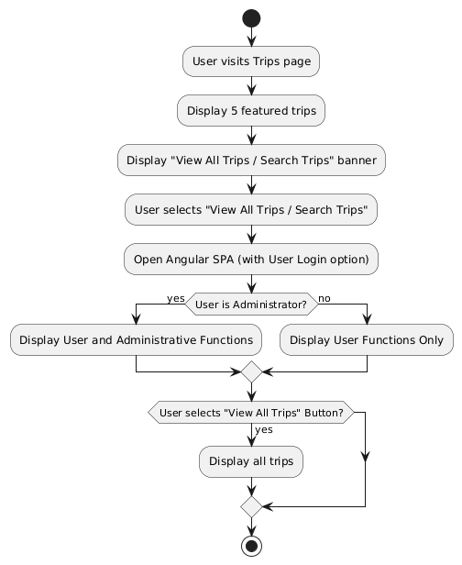

Adding Search, Sort, Filter
This section covers the main goals of the Algorithms and Data Structures section by adding search, sorting, and filtering capabilities to the SPA page. The first step is to modify the Trips fields to use structured data. As most of the fields are initially text, the contents are relatively free-form. To improve search and filtering capability, I will convert fields like the duration field into a numeric field. The resort field can be split into Resort Name and Resort Rating fields, with a plan to make resorts into their own separate records in the database and link those to the relevant trip.

This Search, Sort, Filter Diagram shows the expected operation of the SPA after the new options have been added. Each of the Search, Sort, and Filter options are dynamic and applies instantly to the trips list, allowing the user to combine any and all of the options to find the trips they are looking for.
Search, Sort, Filter Diagram
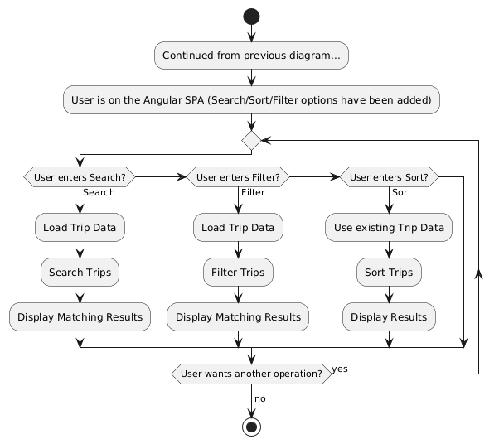

Once the fields are split, the next step is to provide an interface for the user to specify their selections. The trips are displayed centered on the page, three across in each row, with as many rows as needed to display all trips; this format will be retained. In the open space on the left, I will add the new search, sort, and filter options.
The search option will be a live text field that will search the text fields for matching text. The goal is to allow for dynamic searching, with the trips updated as the user enters text. This search will include the tripCode, as administrative users may find it beneficial to be able to locate a specific trip directly.
Below the search field, the filter section will provide filter options for each trip field: Resorts, Rating, Length, Price, and Date. Resort and Rating filters will be dropdown fields with their selections generated dynamically based on the full list of available resorts. Duration and Price filtering are to be provided as Min/Max entry ranges. Date will check for dates that are ahead of (in the future from) the entered date. As search criteria are entered, the list will be updated dynamically to reflect the matching trips.
Sorting will consist of one dropdown that allows the user to select one of the trip fields to sort by and a selection option for Ascending or Descending. When a field or sorting direction is selected, the sorting will be applied immediately.
In this way, the search, sort, and filter options all work together to allow the user to limit the displayed trips based on all the criteria they enter. Naturally, there is the possibility of the user entering criteria that generate no matches. In that case, the application will display a simple text message indicating that there are no matching trips.

For this category of enhancement, consider improving the efficiency of a project or expanding the complexity of the use of data structures and algorithms for your artifact. These are just recommendations. Consider being creative and proposing an alternative enhancement to your instructor. Note: You only need to choose one type of enhancement per category.

Think about what additions to include to complete the enhancement criteria in this category. Since one example option is to port to a new language, that is the kind of scale that is expected. Perhaps you might increase the efficiency and time complexity of an algorithm in an application and detail the logic of the increased time complexity. Remember, you do not need to port to a new language but instead have an equivalent scale of enhancement. Underlying expectations of any enhancement include fixing errors, debugging, and cleaning up comments, but these are not enhancements themselves.

- Explain how the planned enhancement will demonstrate specific skills and align with course outcomes.

  - Identify and describe the specific skills you will demonstrate to align with the course outcome.

The core concepts of this section center around algorithms and data structures; these deal with data manipulation and how data is represented. In this section, I demonstrate my facility with data through how I provide the user with ways to interact with that data. The goal of the enhancement is to allow the user to search, sort, and filter the data. My design showcases how the data manipulation will be dynamic and live, allowing the user to freely combine each aspect to achieve their desired output. A user might search first, then sort, and finally filter, or filter first, then sort. This flexibility is necessary because I recognize that no designer can predict all possible use cases that a user may want to execute. A flexible design that allows the user maximum freedom while still maintaining efficiency is a strong and valuable feature for working with data.
Design, development, and planning also feature among the skills used in this section to meet the course outcomes. By planning to use the existing SPA, I cut development time for the feature. This shows both a knowledge of how to combine similar parts of the project and an understanding that developing a completely new interface is likely to take more time than was available. Determining what can be accomplished in a specific time frame is a necessary skill in professional software development when deadlines and market factors can determine project success or failure as much as code quality.
These considerations are also used when determining how the SPA should process the trip data and when evaluating the trade-offs between performing the operations on the client or through the database. This demonstrates that my design decisions are based not only on providing functionality but also on considering the amount of data being processed, system resources, and the resulting user experience.

  - Select one or more of the course outcomes listed under Category One that your enhancement will align with.

This category's work aligns most strongly with the following course outcomes:

2 - Design, develop, and deliver professional-quality oral, written, and visual communications that are coherent, technically sound, and appropriately adapted to specific audiences and contexts.

As this portion of the project development touches on the user interface, UI design and providing a clear and understandable interface are crucial. This work provides the opportunity to build an interface that is clear in its communication to its user audience and has a professional look that delivers clarity and usability.
The layout of the search/sort/filter data manipulation options will be added along the left-hand side of the page. Displaying options and settings on the left is a familiar design for users, so this layout was chosen not only to provide a professional appearance but also to use that familiarity to improve communication with them.
By making the data manipulation options live and responsive to the user rather than requiring the user to select a "Submit" button to activate them, the user will immediately see the results of their entries. This sort of immediate and clear feedback allows the user to intuitively understand how the interface operates without the need for additional explanations or tooltip icons.

3 - Design and evaluate computing solutions that solve a given problem using algorithmic principles and computer science practices and standards appropriate to its solution while managing the trade-offs involved in design choices.

The choice to build this addition into the SPA and link the SPA to the user website rather than separating the functionality and enhancing only the Express pages with search, sorting, and filtering follows two major computer science practices. First, it makes use of existing code, which decreases build time and improves maintainability.
Second, it efficiently uses the same interface to serve multiple audiences. Instead of building out just a user interface, both users and administrators will gain these benefits. This reduces the work needed to serve both audiences now and reduces future work in the same area by structuring the application to minimize code duplication.
This section also demonstrates the evaluation of trade-offs involved in software design. The existing SPA provides a strong foundation and is better suited to the intended user experience than relying solely on static pages. Browsing and comparing travel packages is expected to be an extended user interaction, making ongoing responsiveness more important than minimizing the initial load time. While an SPA requires additional processing and resources from the user's computer and browser, the improved responsiveness and reduced need for full-page reloads provide greater value for the expected clientele of a high-end travel agency. Given the relatively high value of the services being offered and the expected availability of capable client devices, this trade-off favors a more responsive browsing experience over minimizing client-side resource requirements.

4 - Demonstrate an ability to use well-founded and innovative techniques, skills, and tools in computing practices for the purpose of implementing computer solutions that deliver value and accomplish industry-specific goals.

Delivering value with an enhancement is often considered one of the most significant measures of success. The addition of searching, sorting, and filtering helps accomplish the industry-specific goal of allowing users to locate the trips they want to find. If a customer cannot find a suitable trip, they are unlikely to purchase a trip package from the agency. Likewise, if an administrator cannot find or review the trips they offer, they cannot update trips, remove outdated trips, or evaluate their offerings.
By using the existing Angular, Express, and REST architecture along with the established SPA/client-side interaction, the feature is well-founded in techniques and tools used to build the enhancement: Angular is already used in the SPA, the REST API already provides the interface to the back end, and Express already supports the client-facing website. Using the same architecture structure fits with the way that the code and the folder structure have been developed, which improves the ability of other developers to maintain the code and reduces the need to design a new interface.
The value of this enhancement encompasses not only what is added but also how the enhancements are provided. Developing this feature set for both customers and administrators at the same time solves the same types of issues for both user groups while minimizing the development time required to produce the feature. In every industry, time-to-market is a significant factor, and reducing development time means a shorter time to market and lower development costs. Thus, this enhancement provides real value while minimizing costs.

  - Category Three: Databases

    - Select an artifact that is aligned with the databases category and explain its origin (and categorical alignment).. Submit a file containing the code for the artifact you choose with your enhancement plan. You may choose work from the courses listed under Category One.

For the Databases portion, I will be enhancing the CS-465 Full Stack Development I Travlr website project. As described above, this is a MEAN full-stack application with a customer-facing Express website, an administrative SPA, and a MongoDB database.
To implement the Databases category, this section's work will include adding a booking system to the SPA. This work will cover the full range of program additions, from building out the database collection and booking schema, to creating the CRUD operations for booking entries, adding API routes to allow access by the front end, and updating the front end SPA with the UI required to access all the CRUD operations.
This work meets the alignment for the Databases category by designing a new data model and integrating it with existing data: adding a new booking collection and developing a new set of CRUD operations to support it. This booking system addition requires building an interface across the entire data lifecycle, from the database system through to the UI. It ties into all the previous work by using the refactored API and website, as well as the centralized error handling process.
As shown in the schema diagram, this work demonstrates designing and building a new database schema for bookings by determining what fields a booking needs to contain, as well as what types of data integrity and validation must be applied. As part of this consideration, each booking includes a reference to the trip for which it is booked. This uses an association with a trip entity instead of creating a booking record that contains all the details about the selected trip. A reference is more efficient because it reduces data duplication, which helps maintain data accuracy.
I included a stored value for the estimated trip price to demonstrate how calculated data can be generated from existing database values rather than requiring the user to enter it manually. Storing this value also preserves the price at the time of booking, which can be useful if the trip's price changes later, such as when determining whether the customer received a sale or promotional price.

    - Describe a practical, well-illustrated plan for enhancement in alignment with the category, including a pseudocode or flowchart that illustrates the planned enhancement.

Booking System Collection & Schema
To create a booking system, I need to create the collection and database schema for a booking. This provides the foundation for building out the CRUD operations, API, and UI because it defines the fields that will be present and required for a booking. A booking document will contain an identifier, customer email, customer name, an ID for the associated trip, the booking date, number of travelers, estimated total cost, and booking status.
The new travlr\app_api\models\booking.js file will include the Mongoose booking schema with the structure of the booking document.

The Database entity diagram shows the relationships between the entities in the database that are used by the booking document. Status values and the calculation for the estimatedTotal field are also displayed.
Booking Database Entity Diagram
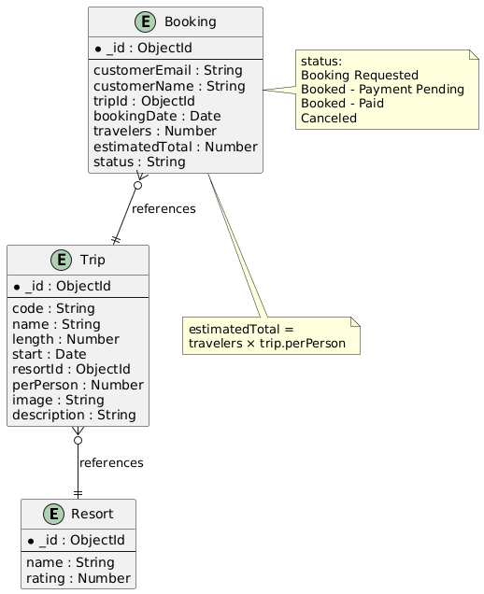

The trip reference and its included resort reference have relational significance; by using a reference, each booking includes an association with the trip it is related to and provides the ability to use that reference to look up the trip when needed without including the full trip data in the booking record.
The estimated total cost will be created by multiplying the number of travelers by the per-person cost of the trip rather than being directly entered. The booking status field will allow four valid values: Booking Requested, Booked - Payment Pending, Booked - Paid, and Canceled.
This work will include seeding the set of initial resorts with their ratings, as well as updating the seeded trips to include the proper references to the seeded resorts.

Booking System CRUD Operations
This step builds out the CRUD operation functions. It adds the database functionality that will be called by the API for creating bookings, reading/retrieving bookings, updating/editing bookings, and deleting bookings. The new travlr\app_api\controllers\bookings.js file will include the controller logic to receive the CRUD requests and handle validation.
Each operation will follow the flows outlined below. Creating a booking will require the basic booking data to be present and that the referenced trip can be located in the database. If required data is missing or the trip cannot be located, an error will be generated that is routed to the centralized error handling process.

Create Booking Diagram
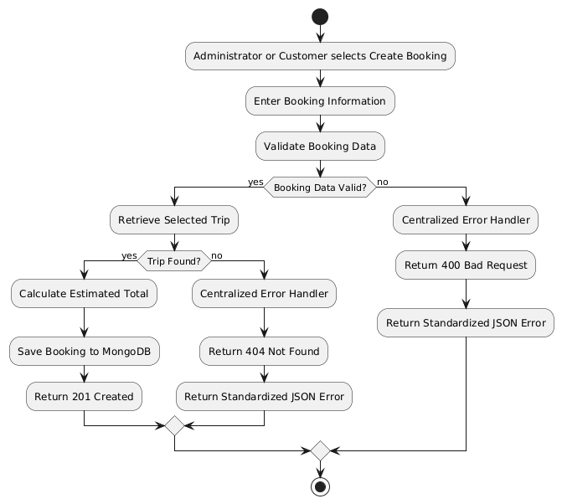

Retrieving one or all bookings will depend on whether a single booking ID is provided. This process will be designed like the current trips retrieval process, where a single booking will be returned if a booking ID is provided, or an array of all bookings will be returned if no ID is provided. Naturally, if an ID is provided but cannot be located, an error will occur that will be routed to the centralized error handling process.

Retrieve Booking Diagram
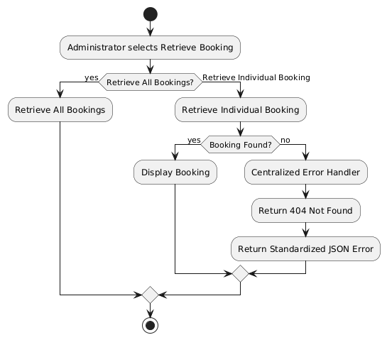

Editing can only be accomplished for one booking entry at a time, so in order to edit a booking, a booking ID must be provided and successfully located. Like the current trip editing, the booking information will then be provided back to the requester, and a new request can be made with updated information to be saved in the database. If the booking is not found or the data provided during the update is invalid, an error will occur and be routed to the centralized error handling process.
Edit Booking Diagram
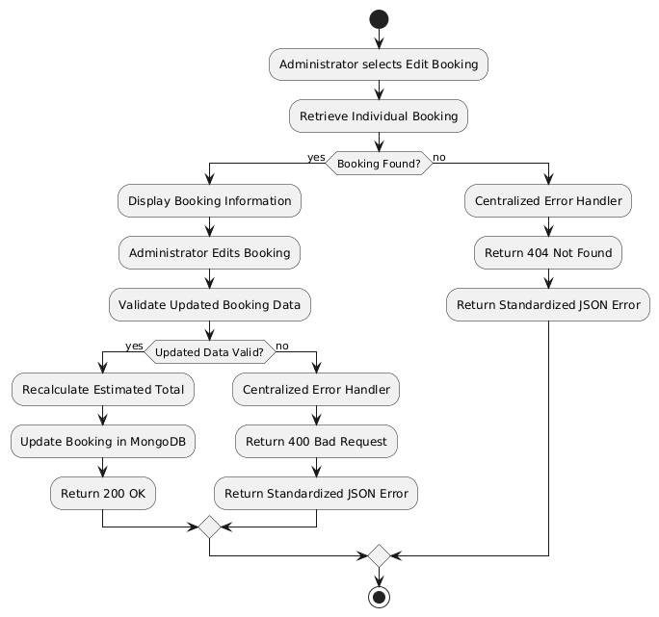

Finally, deletion is fairly simple; it takes a single booking ID and, if found, deletes that booking entry from the database. If the booking ID is not found, an error will occur that will be routed to the centralized error handling process.
Delete Booking Diagram
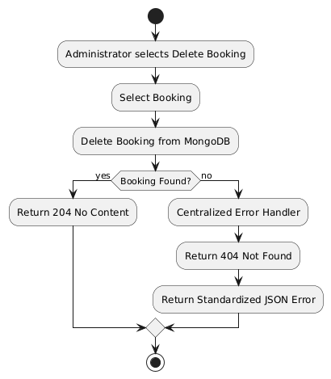

Booking System API
Building out the API includes defining all the endpoints, their HTTP operations, and including authorization protection for endpoints that only administrative users are allowed to access. Customers are only allowed to create bookings, while administrators will be able to create, retrieve, edit, and delete bookings.

NEW API Endpoints Table
Method | Purpose | URL | Notes
POST | Create a new booking | /api/bookings | Create a new booking request from customer-provided booking information.
GET | Retrieve a list of all bookings | /api/bookings | Administrative – Requires valid login  Returns an array of all trip documents stored in the database.
GET | Retrieve a single booking | /api/bookings/:bookingId | Administrative – Requires valid login  Returns an array that includes only the single document specified by the bookingId provided in the URL
PUT | Edits an existing booking | /api/bookings/:bookingId | Administrative – Requires valid login  Allows editing an existing trip specified by the bookingId provided in the URL
DELETE | Deletes a single booking | /api/bookings/:bookingId | Administrative – Requires valid login  Removes a single existing trip specified by the bookingId provided in the URL

Each of these endpoints will be added following the same logic that the trips endpoints currently use. The travlr\app_api\routes\index.js file will be updated with the new routes to direct the URL to the code logic that was created in the new files built in the Collection & Schema and API sections above.

Booking System UI
Integration with the existing UI will be accomplished by adding a Book Trip button next to each trip. This button will be shown to both administrators and regular customers. Clicking this button will take the user to a form where they can fill out the pertinent information for their booking: Customer Email, Customer Name, Booking Date, and Number of Travelers. After booking, a confirmation screen will be displayed. The Book Trip form will follow the same format that the current edit trip form uses.

User Booking UI Diagram
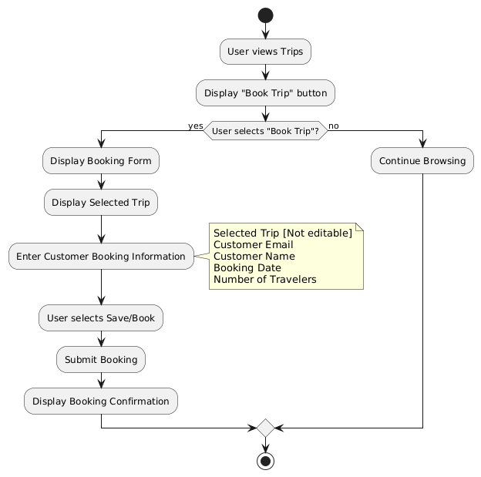

Administrators will have the ability to view a list of all bookings and be able to select a booking from that list to edit or delete. A new UI form will be created to list all the bookings, along with options to delete or edit them.
The Book Trip form will also be reused for the administrative interface to allow editing of the booking information. Administrator-only fields will be hidden from customers but shown to administrators. The calculated Estimated Total Cost field will be displayed but remain uneditable.

Admin Booking UI Diagram
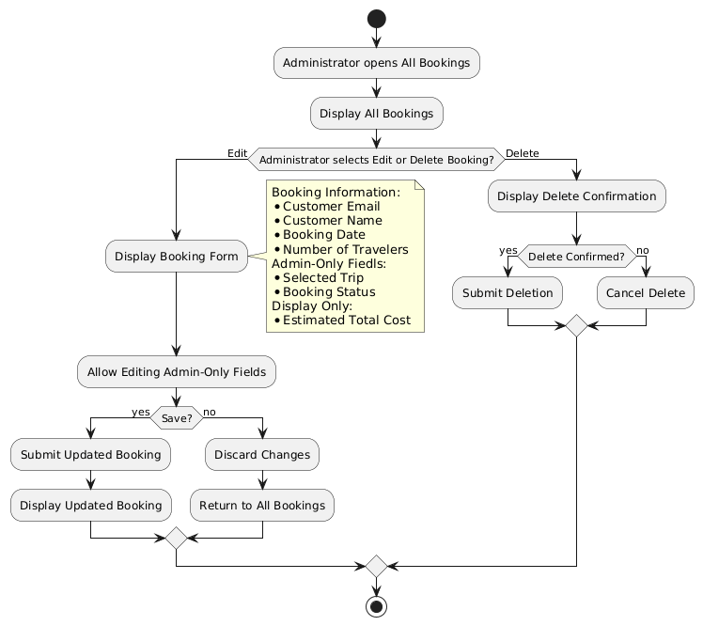

For this category of enhancement, consider adding more advanced concepts of MySQL, incorporating data mining, creating a MongoDB interface with HTML/JavaScript, or building a full stack with a different programming language for your artifact. These are just recommendations; consider being creative and proposing an alternative enhancement to your instructor. Note: You only need to choose one type of enhancement per category.

Think about what additions to include to complete the enhancement criteria in this category. Since one example option is to port to a new language, that is the kind of scale that is expected. Perhaps you might increase the efficiency and time complexity of an algorithm in an application and detail the logic of the increased time complexity. Remember, you do not need to port to a new language but instead have an equivalent scale of enhancement. Underlying expectations of any enhancement include fixing errors, debugging, and cleaning up comments, but these are not enhancements themselves.

    - Explain how the planned enhancement will demonstrate specific skills and align with course outcomes.

      - Identify and describe the specific skills you will demonstrate that align with the course outcome.

The focus of this section is developing an entirely new feature that covers the entire full-stack application and incorporates it into the existing architecture. This naturally demonstrates my facility with feature design, full-stack development, and overall software development. Full-stack development includes database management and schema creation, client/server interfaces, such as the REST API, and the user-facing UI of the website. While the MEAN stack does use JavaScript to simplify the process of developing the various aspects, each portion of the full stack utilizes different skills.
Designing a database schema includes understanding how the database functions and what types of relationships the stored data must maintain. In this project, I include a reference from the booking entity to a trip entity in order to provide a necessary relationship without the need for data duplication.
The client/server interface using the REST API requires knowledge of how endpoints function, their proper use, and the various HTTP methods that can be used with them. The design here includes a new endpoint URL for bookings that handles all needed CRUD operations. The design demonstrates my knowledge of how to incorporate all the required functionality in a single endpoint structure without the need to build out multiple URLs or endpoints, which would increase maintenance requirements and reduce the clarity of the API.
Finally, the UI aspect requires an understanding of how users interact with applications, as well as how a website should be formatted to best provide the feedback the user needs. UI design can be exacting, and this demonstrates my ability to provide good communication to a diverse audience.

      - Select one or more of the course outcomes listed under Category One that your enhancement will align with.

This category's work aligns most strongly with the following course outcomes:

1 - Employ strategies for building collaborative environments that enable diverse audiences to support organizational decision-making in the field of computer science.

Communication and collaboration exist both within an organization and between organizations and external entities. Building out a booking interface connects customers with Travlr employees, allowing customers to communicate their travel plan selections. One of the most important parts of a travel website for a business is enabling customers to use their service. By building an interface between the customer and the employee, the booking system feature allows them to begin the collaboration process of building out a planned vacation trip. The structured submission form allows users to quickly know what information the company needs to assist them in booking, and employees receive all the initial information they need to reach out to the customer and start the booking process.

5 - Develop a security mindset that anticipates adversarial exploits in software architecture and designs to expose potential vulnerabilities, mitigate design flaws, and ensure privacy and enhanced security of data and resources.

The booking feature is both new and extensive, crossing all parts of the full stack. The feature will require testing and verification of each aspect, from ensuring the database is populated with the correct seed data and the schema enforces required data, through testing all the API endpoints and methods, and finally verifying that the webpage UI functions correctly and displays the correct data.
Security often starts at the lowest level, the database. The design includes a schema that will enforce required fields and use appropriate data types. By validating the data before it is entered into the database, the schema reduces the possibility of invalid or malicious data being stored.
The design includes a full set of new endpoints, with diagrams that indicate the standard usage of HTTP responses. Following established API design practices helps reduce opportunities for potential abuse or exploitation. Error responses are one way that internal information can leak, creating a security gap. By using established response standards and a centralized error handler, the opportunity for such leaks is reduced.
Adding authentication to sensitive endpoints of the API also improves security. By blocking unauthorized users from accessing endpoint methods that control sensitive database operations, the opportunity to exploit the system is reduced.
At each stage, security flaws can occur, and opportunities to use best practices exist. By following best practices and performing testing, I help demonstrate the mindset necessary to detect flaws and enhance the security of the application.

- ePortfolio Overall Skill Set

  - Accurately describe the skill set to be illustrated by the ePortfolio overall.
    - Skills and outcomes planned to be illustrated in the code review

The ePortfolio will showcase my ability to communicate and demonstrate the software skills I have acquired to a professional audience. Through the portfolio content, I show the types of projects I am capable of creating and maintaining, not just in code but also in documentation. Code needs to be functional, but too often, the documentation of the code is left as an afterthought. In my portfolio, I will show that my documentation is developed alongside the coding process.
Design documentation is the first line of communication with both management and developers. By showcasing effective design documentation, I can demonstrate that I can communicate across the range of primary audiences. Similarly, code comments supply developers with insight into the code that was created and allow them to quickly understand what that code is intended to do. In the current climate of regularly changing jobs, leaving behind solid documentation that future employees can easily utilize can be a strong point in a job applicant's favor. Overall, my use of good documentation skills demonstrates professional communication that makes software easier for other developers to understand and maintain.
The code review will provide an opportunity to demonstrate my technical and communication skills directly by stepping through the code areas that will be impacted by each of the three development areas. I plan to show the code and talk through how each section currently works and the areas where the code needs improvement. This will include discussion of my designs as well as the current state of the code. Using the code review, I can showcase my understanding of the application project as well as demonstrate my ability to discuss a plan of action to update the code for each improvement. This portion will highlight my ability to provide an oral overview while also demonstrating an in-depth understanding of the code.

    - Skills and outcomes planned to be illustrated in the narratives

The narratives are designed to allow reflection on the process of development and to showcase the skills gained and how the overall enhancements contribute to meeting the course outcomes. As such, the narratives will demonstrate how my design skills have added value to the functionality and how, in doing so, I maintained security-focused mindset, keeping with the industry standard of building security in from the ground up.
I also expect to show what I learned from the enhancement process. This shows a growth mindset and an eagerness to learn, both of which are important skills to show prospective employers. As a computer scientist, I am involved in continuous learning, which comes not only from deliberate class exercises but from direct, hands-on development of my own code and learning from the development process. Showing that I understand what happened in the development process and have added it to my store of knowledge shows my ability to critically analyze the outcomes and improve my methods along the way. The narratives will therefore demonstrate skills in critical analysis, problem-solving, technical decision-making, testing, and evaluating the results of my development decisions

    - Skills and outcomes planned to be illustrated in the professional self-assessment

Throughout the courses I have taken at SNHU, I have been able to demonstrate the skills and abilities that I have developed during my tenure in the software industry. I know that my greatest strengths lie in logical thought, organization, and planning. From a software perspective, completing the program coursework has given me confidence that I can successfully enter the field as a developer. In my current position, I communicate better with developers by drawing on my own experiences from the course.
The most recent work with full-stack development, as well as the introductory work for the capstone course, has shown that planning is critical. By developing a plan ahead of time that ensures I have known steps to take, I have been able to budget my time and develop more complex applications than I would have if I had not created designs ahead of time.
The coursework has also given me opportunities to apply these strengths to increasingly complex problems. Organization has helped me break larger projects into manageable components, while planning has allowed me to establish the steps and dependencies needed before beginning development. My focus on logical design has helped me evaluate how those components should work together and consider the consequences of design decisions before implementing them. These skills have been reinforced through work with algorithms and data structures, software engineering, databases, and security, where developing a successful solution requires more than simply writing functional code.
Therefore, my professional self-assessment will include reflections on how I have used my abilities to organize, plan, and provide logical designs to meet the required outcomes of the course, such as fostering collaboration, utilizing proper design, and maintaining a security mindset.

